# GME SCOUTS INVITE ALL ADULT LEADERS & HELPERS TO THE ANNUAL WINTER MET

15 – 19 FEBRUARY 2020 LOCHEARNHEAD

WINTER SKILLS

MEET SCOTLAND

# 

# 

# 

# 

# 

# 

# 

# 

# 

# 

# 

# 

# 

# 



# *Want to learn about winter walking?*

***Want to consolidate your abilities?***

***Want to gain some new skills?***

The course is split into three groups:

1. 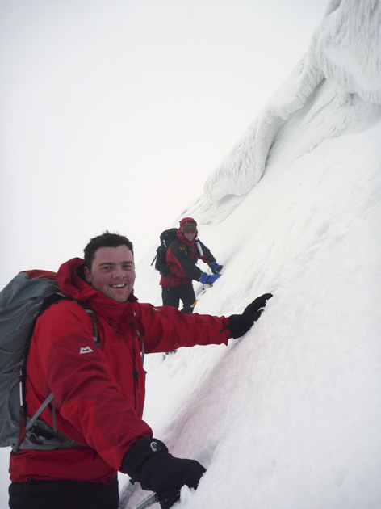**Those just wanting to go winter walking who have limited experience and would like to learn what is involved**
2. **Experienced winter hill walkers who want to just go for   
   a walk / climb with other experienced people**
3. **Further skills sessions for those wanting to advance   
   their knowledge, or to show them what’s needed for   
   a winter hillwalking permit.**

The cost for **4 nights is £140**, or £35 per day.   
This is full board and includes bunkhouse accommodation and all food. We need a non-refundable £20 deposit with your booking.

The course will be held at the Hertfordshire Scout Centre - Lochearnhead Station. See their website for details <http://www.hertfordshirescouts.org.uk/activity-centres/lochearnhead/>

Activities on the hill are weather dependent. We will aim to do full winter hill days on Sunday, Monday and Tuesday, and a shorter day on Wednesday to allow for the long journey home. You must be prepared for long and strenuous hill days carrying a heavy sack. We may have to climb to 700m just to reach the snowline before starting any of the skills workshops, **it is therefore important that you are fit and used to hillwalking**. We will do at least one long mountain ridge during the course (weather allowing!).

TO BOOK A PLACE, PLEASE FILL IN THE ATTACHED FORM…

I wish to attend **Winter Skills…**

15 – 19 FEBRUARY 2020 LOCHEARNHEAD

WINTER SKILLS

MEET SCOTLAND

# 

# 

# 

# 

# 

# 

# 

# 

# 

# 

# 

# 

|  |  |
| --- | --- |
| **My name** |  |
| **My address** |  |
| **My mobile number** |  |
| **My email** |  |
| **My Scout position, group & district.** |  |
| **My next of kin’s name and contact details** |  |
| **Health and Dietary matters that we need to know about** |  |
| **My hill walking experience and permits held.** |  |

**Which option do you wish to take part in?** (please tick)

I have limited experience and just want to get out and learn the basics

I am an experienced winter hill walker and want to go for a walk / climb with others

I would like to learn some skills that will help me get a winter hillwalking activity permit

**How long for:** (please tick)

4 nights: Saturday - Wednesday  3 nights: 2 nights:

**Equipment:**

**Ice axe:**  Have own  Need to hire at £5

**Crampons:**  Have own  Need to hire at £5

**Helmet:**  Have own  Need to hire at £5

**Car sharing:**

Do you have a car? ***Y / N*** Are you happy to share travelling? ***Y / N***

What time do you think you will leave Manchester? ___________

**Fees:** Hire of equipment £   
 2 nights @ £70, 3 nights @ £105 or 4 nights @ £140 £   
 **Total: £**

**Deposit paid:** (cheques payable to GMECSC, minimum £20.00, non-refundable) . This can be BACS, details on request

**£______**

**Signed:**  **Date:**

**PLEASE RETURN THIS FORM WITH YOUR DEPOSIT TO:** [**activities@gmescouts.org.uk**](mailto:activities@gmescouts.org.uk) **By post to; Keith Hampson,** 11 Gladstone Grove, Heaton Moor SK4 4BX